**DAY 2 (DIY)**

**Q.1.** Open file /etc/passwd in vi editors and search string ‘nologin’ from top to bottom and from bottom to top.

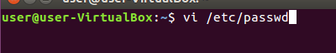

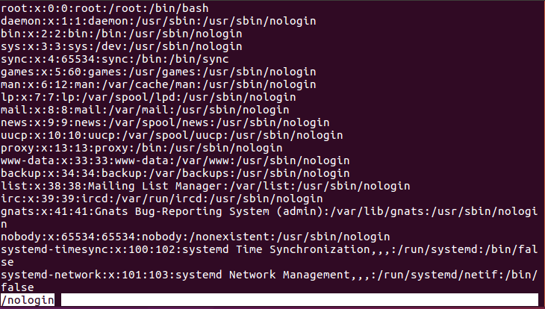

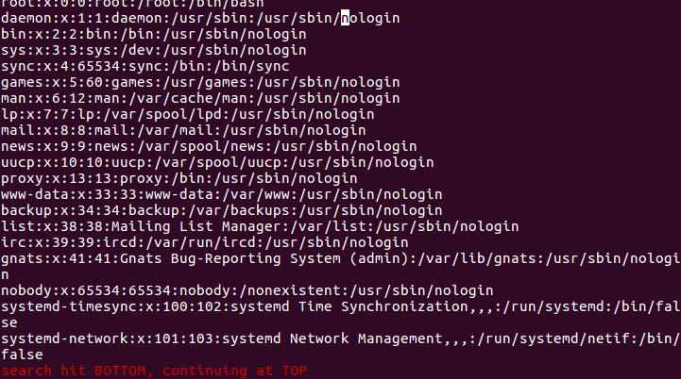

**Q.2.**Open the file /var/log/messages in the vi editor and delete line no.150



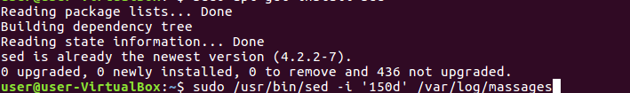

**Q.3.** Write a shell script to add 2 numbers.

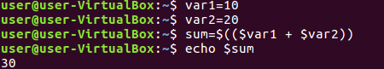

**Q.4.** Which run level will reboot the system

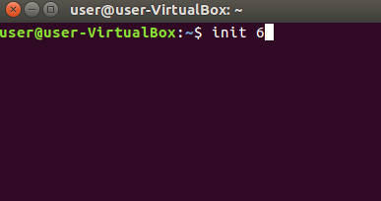

**Q.5.** User root want to copy /etc, including all subdirectories and files to /tmp. How will you achieve this task?

